## METEC Khanacross Kilsyth, Sunday 14th April 2019

## Presented by Peugeot Car Club of Victoria

The Event will be held under the FIA International Sporting Code including Appendices and the National Competition Rules (NCR) of the Confederation of Australian Motor Sport Ltd (CAMS), the current Khanacross regulations, these Supplementary Regulations, and any Further Regulations and Bulletins that may be issued. This Event will be conducted under and in accordance with CAMS OH&S, CAMS Safety 1st and Risk Management Policies, which can be found on the CAMS website at [www.cams.com.au](http://www.cams.com.au). The Promoter reserves the right to refuse any entry in accordance with NCR 83 of the current CAMS Manual of Motor Sport and to cancel the meeting if, in its opinion, insufficient entries are received. The Promoter reserves the right to cancel, postpone or abandon the event in accordance with NCR 59 of the current CAMS Manual of Motor Sport.

|  |  |  |  |  |  |  |  |  |  |  |  |  |  |  |
| --- | --- | --- | --- | --- | --- | --- | --- | --- | --- | --- | --- | --- | --- | --- |
| **Date of Event** | Sun 14th April 2019 | CAMS Permit No. | **3** | **1** | **9** | **/** | | **1** | **4** | **0** | **4** | **/** | **0** | **3** |
| **Venue** | METEC Driver training school – 112 Colchester Rd Kilsyth 3137 | | | | | | **Surface** Sealed (bitumen / concrete) | | | | | | | | |
| **Event Type** | **Multi-Club Khanacross** | | | | | |  | | | | | | | | |
| **Promoter/Organiser** | Peugeot Car Club of Victoria, Inc. | | | | | | | | | | | | | | |
| **Clerk of the Course** | Phil Torode (Judge of Fact) Licence No: 9944011 - 14 Nott St Balwyn 3103. – [phil@bidwriter.com.au](mailto:phil@bidwriter.com.au) phone 0432 107301 | | | | | | | | | | | | | | |
| **Entry Secretary** | Send entries to: Glad Fish - 66 Blue Ridge Rd. Dewhurst 3808 - [gladfish@netspace.net.au](mailto:gladfish@netspace.net.au) phone 0410 148 058  Preferred payment method - EFT to BSB 033-070, PCCV account: 730763 (Use reference: Khana plus surname e.g., KhanaJones and send proof of payment with entry). Cheques are to be made payable to **Peugeot Car Club Victoria Inc**. | | | | | | | | | | | | | | |
| **Entries open** | Upon issue of these regulations. | | | | | | | | | | | | | | |
| **Entries close** | 9:15am Sun 14th April 2019 | | | | | | | | | | | | | | |
| **Maximum entries** | 50 | | | | | | | | | | | | | | |
| **Entry fee** | $80 adult / $40 junior – Entries received after Friday 12th April will cost $100 adult / $50 junior. | | | | | | | | | | | | | | |
| **Entries** | Up to 4 adults and any number of Juniors may compete in any vehicle, if this is indicated on the entry form.  Entries (on the official printed or electronic on-line entry form and accompanied by payment or proof of payment) will be accepted in order of receipt. | | | | | | | | | | | | | | |
| **Minimum CAMS licence requirement** | L2NS/L2NSJ | | | | | | | | | | | | | | |
| **Compulsory Drivers’ Briefing** | 9:45am at the Event check in table. | | | | | | | | | | | | | | |
| **Document Verification** | Documentation will open at 8:15am and conclude at 9:15am. Presentation of current CAMS licence and current CAMS Car Club Membership will be required for verification. Documentation must be completed for all Crew before the Vehicle is presented for Scrutiny. | | | | | | | | | | | | | | |
| **Vehicle Requirements / Vehicle Scrutiny** | Scrutiny will open at 8:30am and conclude at 9:30am. Drivers of vehicles with a CAMS Log Book must present that Log Book to the Scrutineer. Vehicles will be checked for safety prior to competition and for compliance with General Requirements for Cars and Drivers Schedule A and Group 4H of the current CAMS Manual of Motor Sport.  Fuel must comply with Schedule G of the current CAMS Manual.  Vehicles must be adequately muffled to comply with Vic Roads noise restrictions.  **A Fire Extinguisher complying with AS1841 must be securely mounted as per NCR’s within reach of the Driver.** | | | | | | | | | | | | | | |
| **Apparel** | All apparel, **including Helmet**, must comply with Schedule D of the current CAMS Manual of Motor Sport. Drivers of open Vehicles and specials are required to comply with Level D outerwear (i.e., clothing from ankles to neck to wrists). Clothing of flammable synthetic material, such as nylon, is not acceptable. | | | | | | | | | | | | | | |
| **Classes** | As per current General Information - see next page – based on engine capacity, not wheel base. | | | | | | | | | | | | | | |
| **Event Conditions** | Results shall be determined by the lowest aggregate of elapsed times on the tests completed, plus any penalties. | | | | | | | | | | | | | | |
| **Event Schedule** | Competition will commence at approximately 10am following Drivers Briefing. A 30-minute (approx.) lunch break will start after completion of the last test to commence before 12noon. No new test will be started after 4pm. | | | | | | | | | | | | | | |
| **Other Regulatory Conditions (Awards, restrictions etc)** | Awards will be provided for each class.  Drivers 12 and 13 years of age must be accompanied by an experienced Instructor, approved by the Clerk of the Course.  This Event will include a Motor Sport Passenger Ride Activity (MSPRA) which shall be run under and in accordance with the CAMS MSPRA Policy. Passengers are only allowed where their role is as an ‘Instructor’.   1. A Briefing must be attended by each Driver and Passenger (and guardians of each Passenger if Passenger is under 18 years of age) conducted by the Clerk of the Course prior to the MSPRA commencing. 2. Instructors must: 3. Be experienced and have the permission of the Clerk of Course. The suitability of the Passenger is at the discretion of the Clerk of Course. 4. Wear the same protective gear as a Driver in accordance with Schedule D of the current CAMS Manual of Motor Sport. 5. Be fitted and restrained as required for each Automobile with consideration for their physical attributes. 6. Complete a Passenger Ride Entry Form and disclaimer. 7. Drivers must fill out a Passenger Ride Entry Form to ride as a Passenger. 8. Vehicles and Apparel used must pass Scrutiny. 9. Vehicles shall only carry one Passenger at a time, unless otherwise approved by CAMS.   Certain public, property, professional indemnity and personal accident insurance is provided by CAMS in relation to the event. Further details can be found in the CAMS Insurance Handbook, available also [www.cams.com.au](http://www.cams.com.au)  Any holder of a CAMS ‘Competition’ or ‘Officials’ licence (or equivalent licence issued by another ASN) may be tested for the presence of drugs (or other banned substances) and subject to a penalty(ies) for a breach in accordance with the CAMS Anti-Doping Policy and/or the CAMS Illicit Drugs in Sport (Safety Testing) Policy as published on the CAMS website. Consumption of alcohol in the paddock, pits or any section of the competition venue/course under the control of the Officials is forbidden until all competition is concluded each day. Accordingly, any holder of a CAMS ‘Competition’ or ‘Officials’ licence (or equivalent licence issued by another ASN) may also be tested for the presence of alcohol by a CAMS Accredited Testing Official (CATO) in accordance with the CAMS Standard Operating Procedure for Breath Alcohol Testing. | | | | | | | | | | | | | | |
| **Protests** | Any protest must be lodged in accordance with Part XII of the current NCRs. | | | | | | | | | | | | | | |

#### METEC Khanacross Kilsyth

#### Sunday 14st April 2019

#### Presented by Peugeot Car Club of Victoria

###### GENERAL INFORMATION

CLASSES are based on engine capacity

**Class A:** Up to 2 litre —Engine Over Driven Wheels

**Class B:** Up to 2 litre —Engine Away from Driven Wheel

**Class C:** Above 2 litre —Engine Over Driven Wheels

**Class D:** Above 2 litre —Engine Away from Driven Wheels

**Class E:** All Wheel Drive Production Vehicles

**Class F:** Specials / and Non-production cars*.

**Class J:** Juniors under the age of 18 as of the first round of the year.

**Class L:** Ladies

**METEC LOCATION**

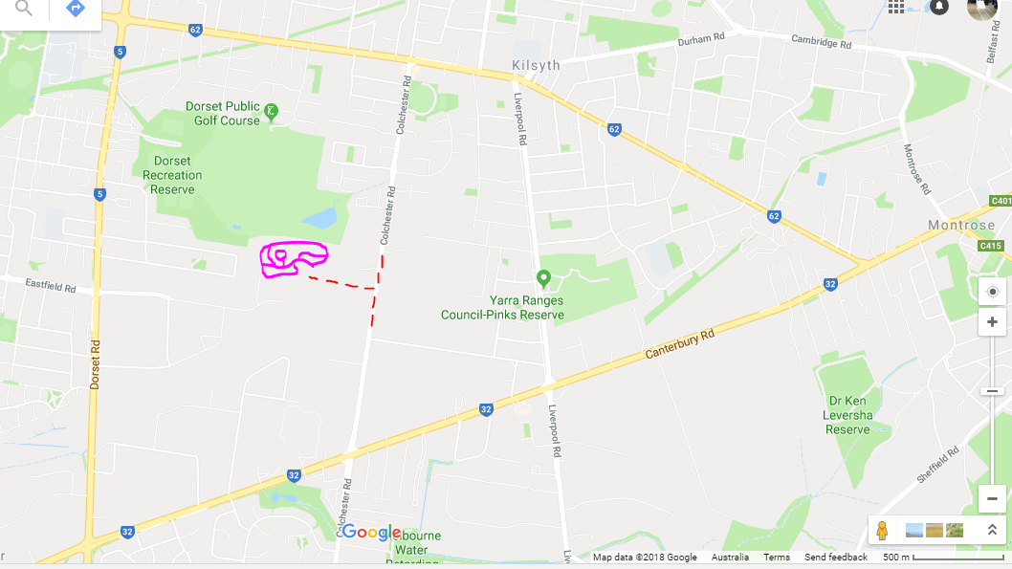

**TIMING** Timing will be electronic backed up by hand held stop watch.

**CATERING/FACILITIES** Toilets are available at the venue. Food and drinks will also be available to purchase at the venue.

**PHOTOGRAPHY** By entering the event, all participants acknowledge that PCCV may photograph or video them participating in this event and use that image in promoting or advertising the Club and its activities including but not limited to Club Magazine, Club Website, articles for inclusion in news and other media.

**CLUB WEBSITE** The PCCV website: <http://www.pccv.org/>

**GROUP 5** **WEBPAGE** For Calendar, G5 Committee, Event Supp Regs and Series Results: <http://ffcc.com.au/group-5/>.

**MOTORKHANA VIC** **WEBSITE** For the full Victorian Motorkhana Calendar: <http://www.motorkhanavic.com.au>